**Experiment with different layouts and color schemes for an app. Collect user feedback on aesthetics and usability using GIMP(GNU Image Manipulation Program (GIMP).**

**AIM**: The aim is to trial different app layouts and color schemes and evaluate user feedback on aesthetics and usability using GIMP.

**PROCEDURE**:

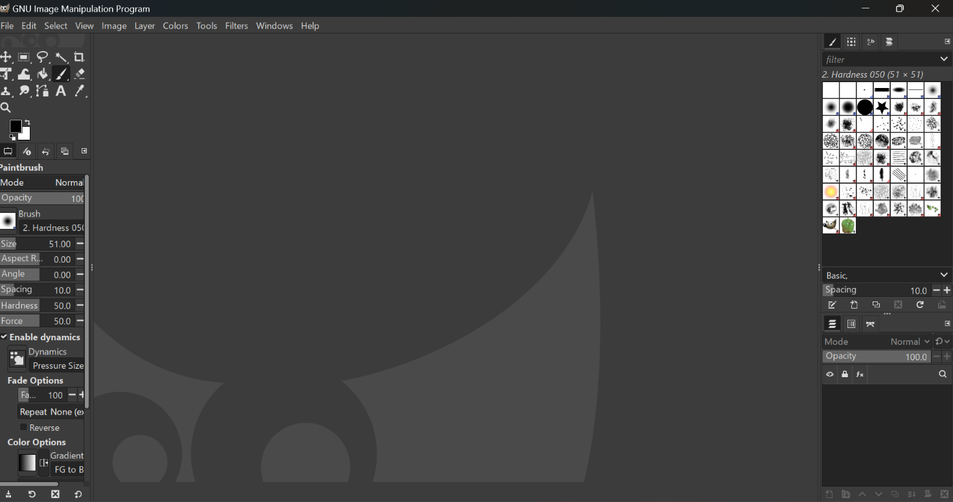STEP 1: Install GIMP.

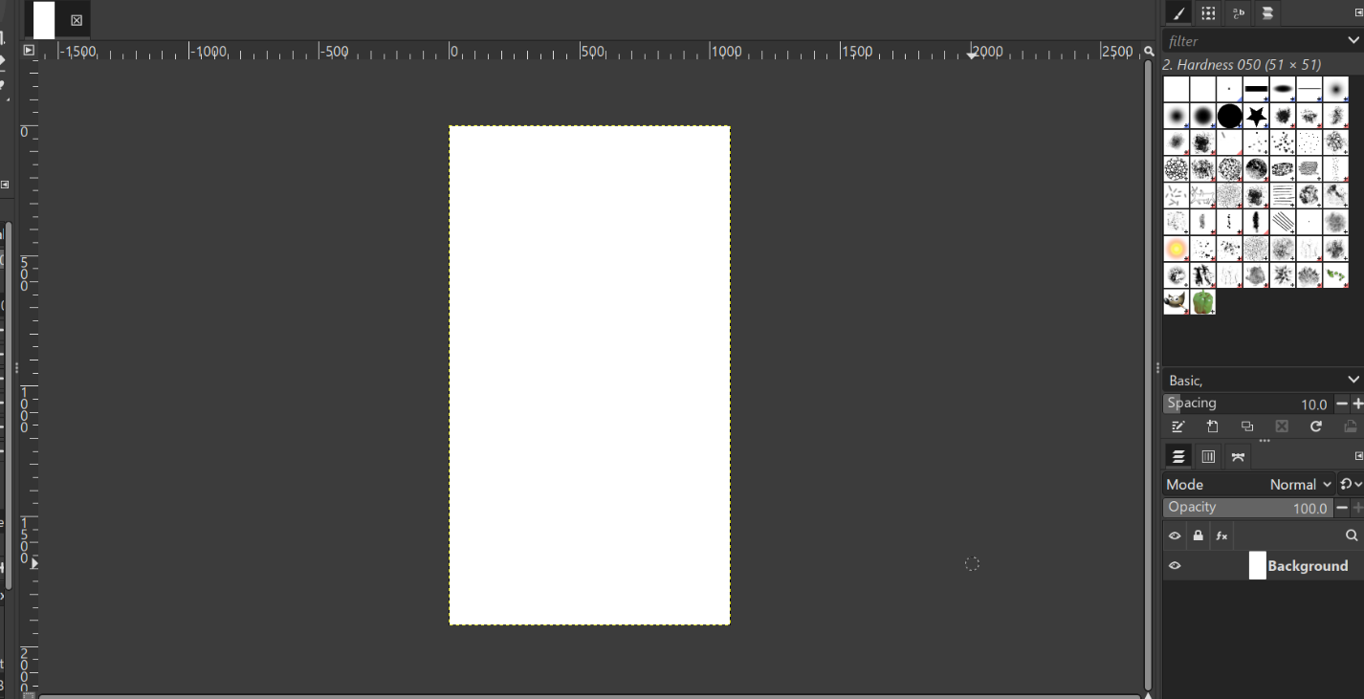STEP 2: Create a new project

STEP 3: Design the Base Layout

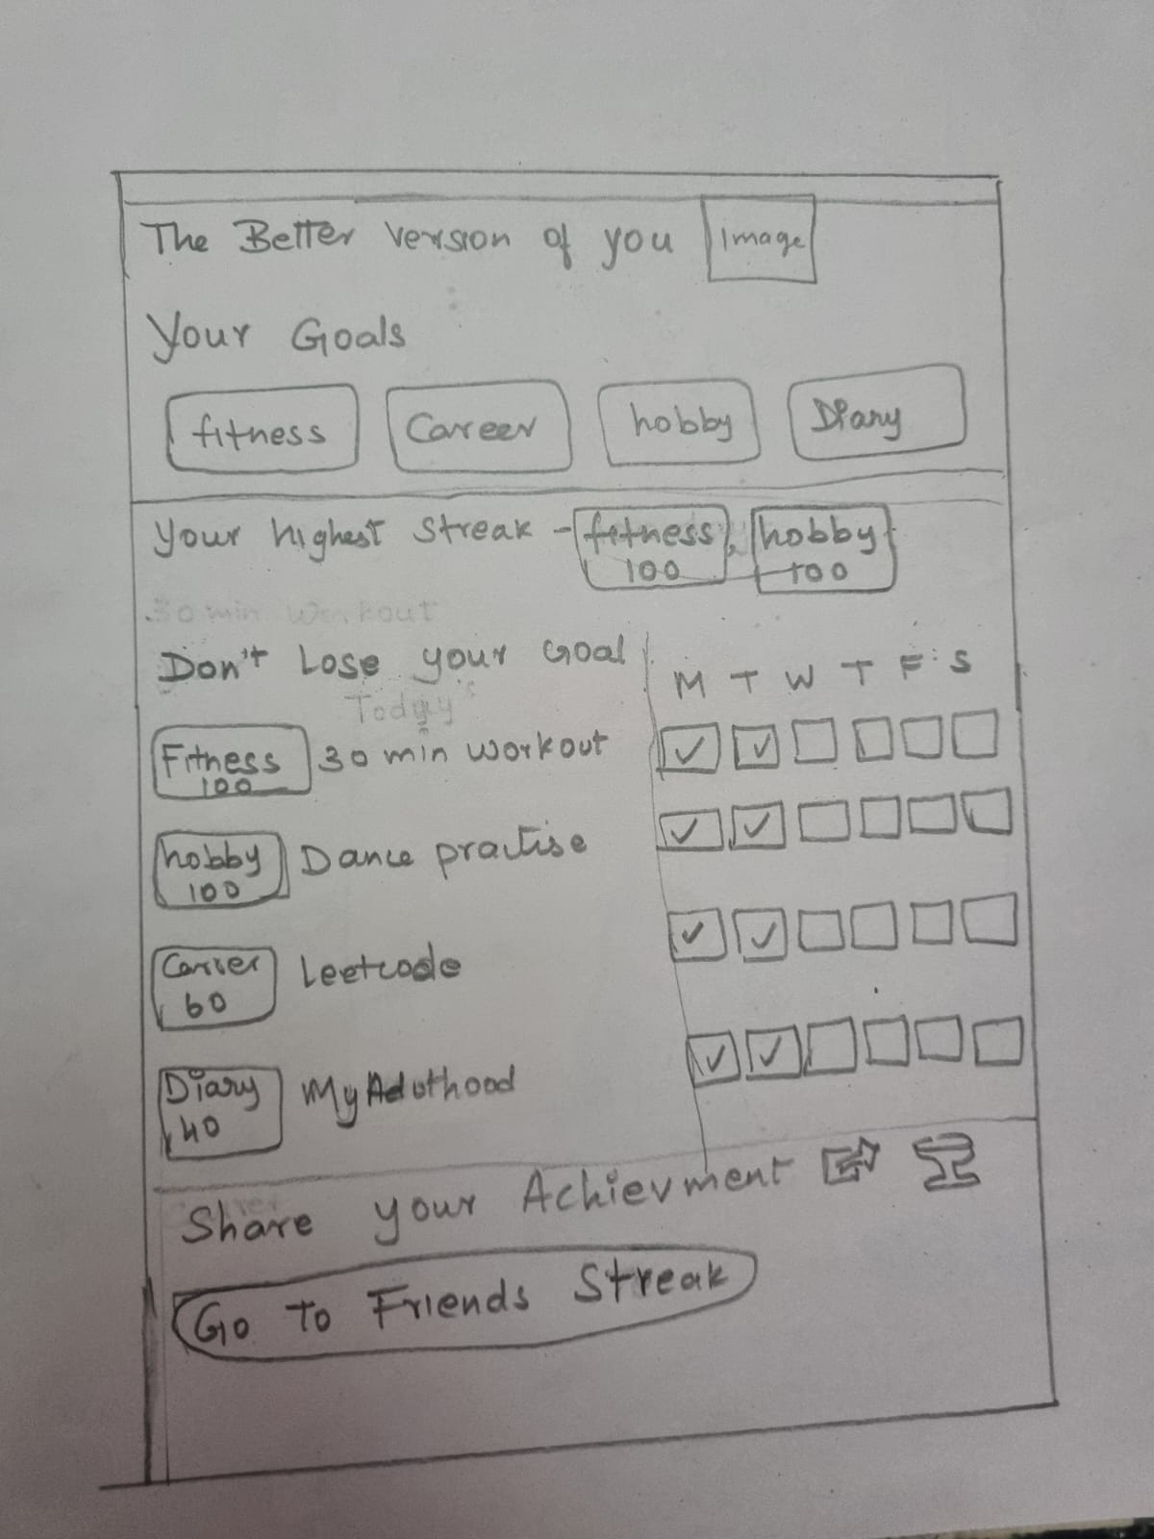I am going to design a streak maintainance app with simple layout. This is the wireframe of my app.

1. Create the Base Layout:

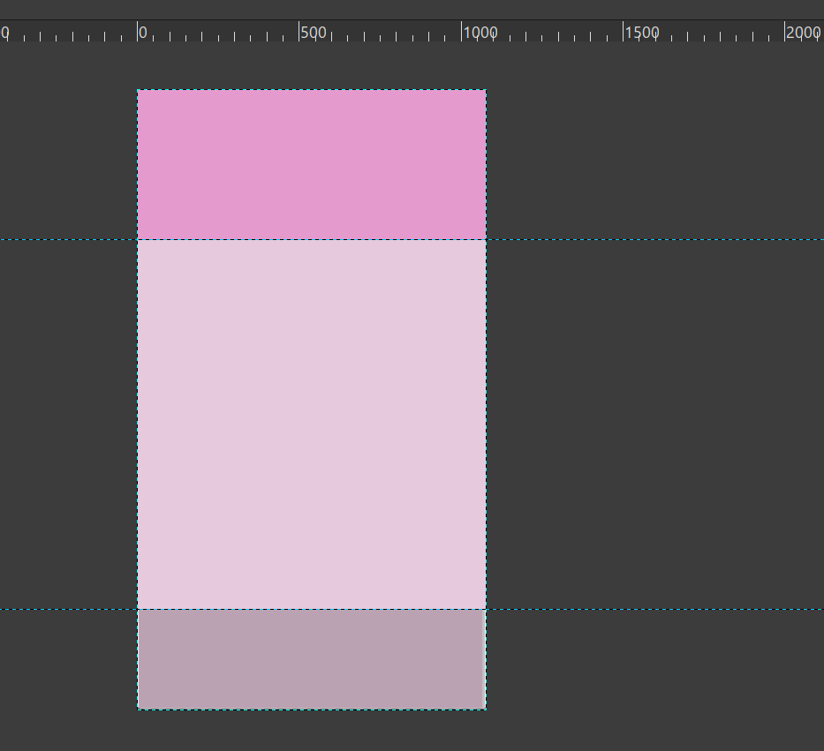

2. Add UI Elements:

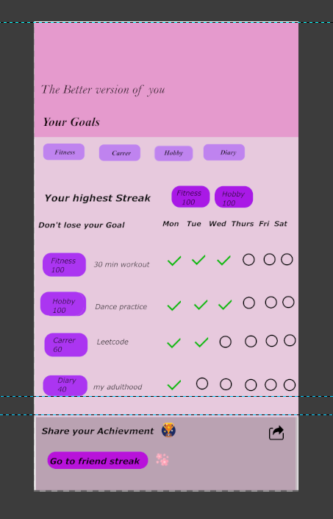

3 Organize layers

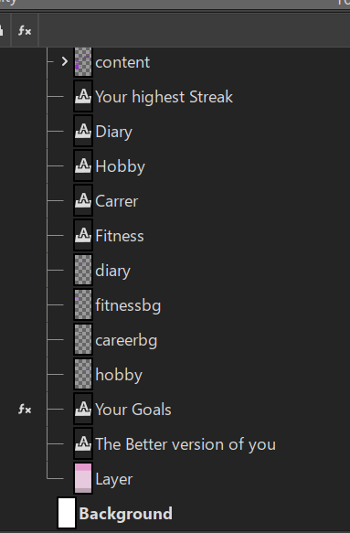

STEP 4: Experiment with Color Schemes.

Layout1

Layout2

Layout 1 Layout 2

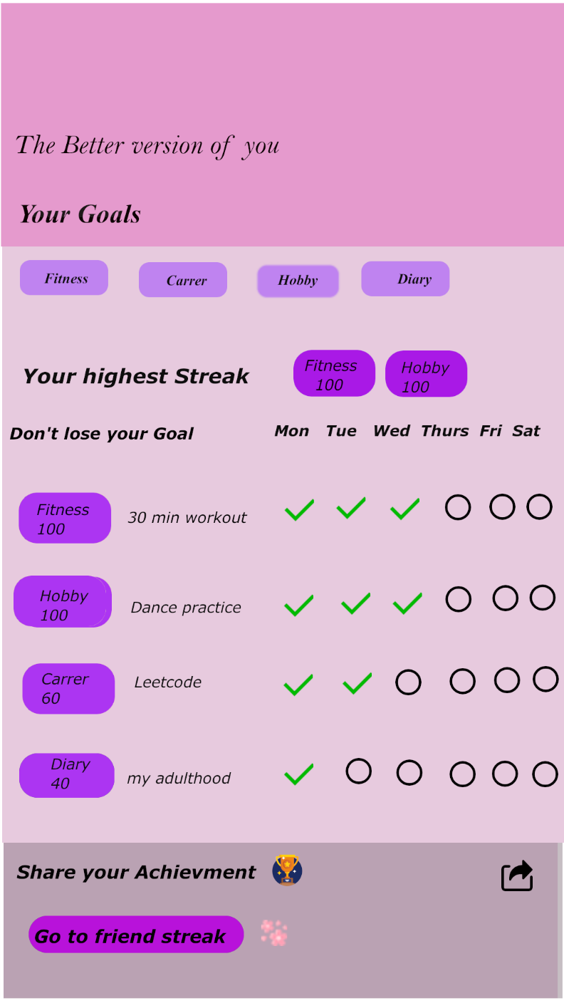

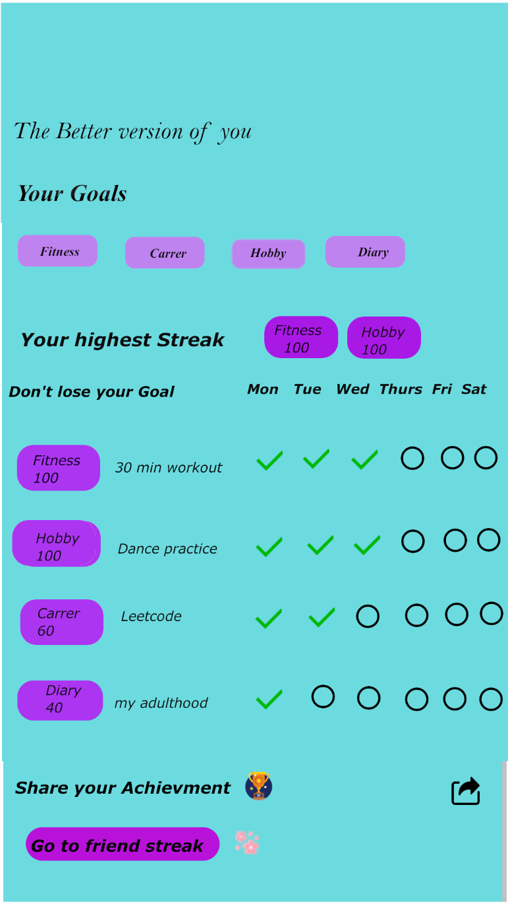

Layout 3

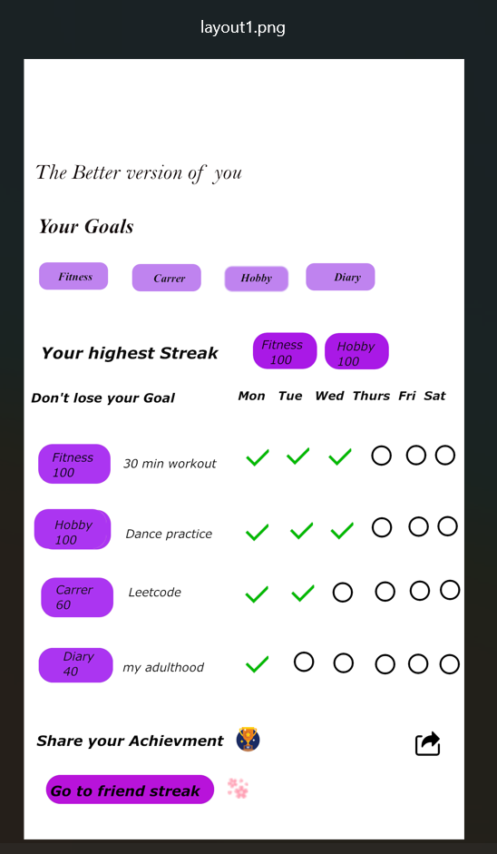

STEP 5: Collect User Feedback

I have created a feedback form using tally.

This is the link of the form.

https://tally.so/r/mOrkVM

This is the responses

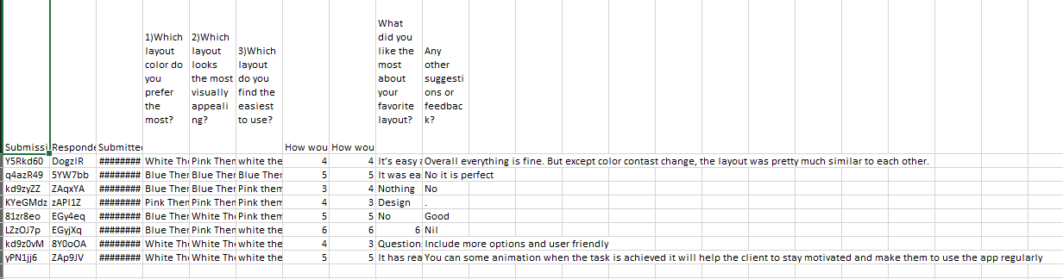

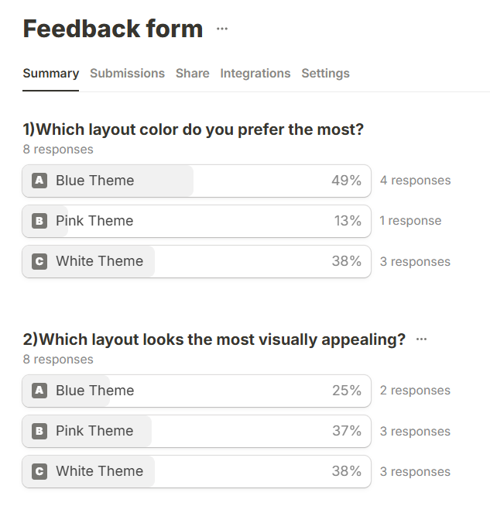Summary

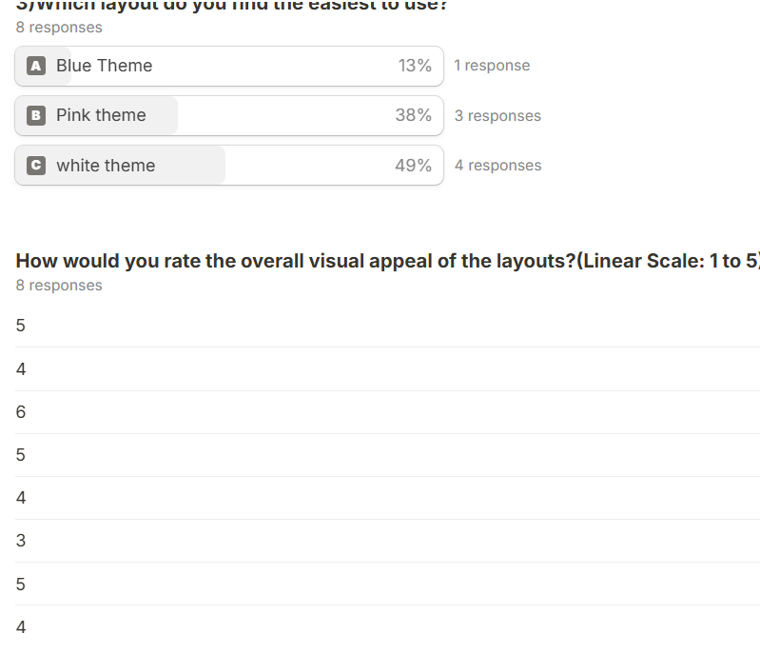

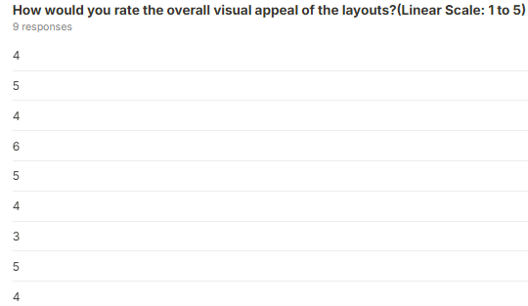

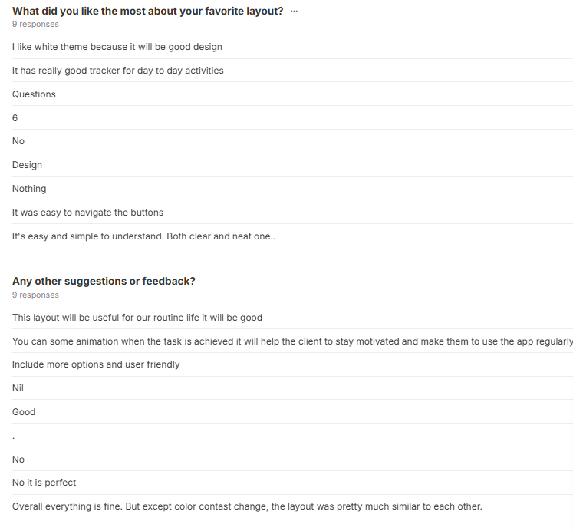

STEP 6: Iterate and Refine

1. Refine the Design:

I made some adjustments based on the feedback.

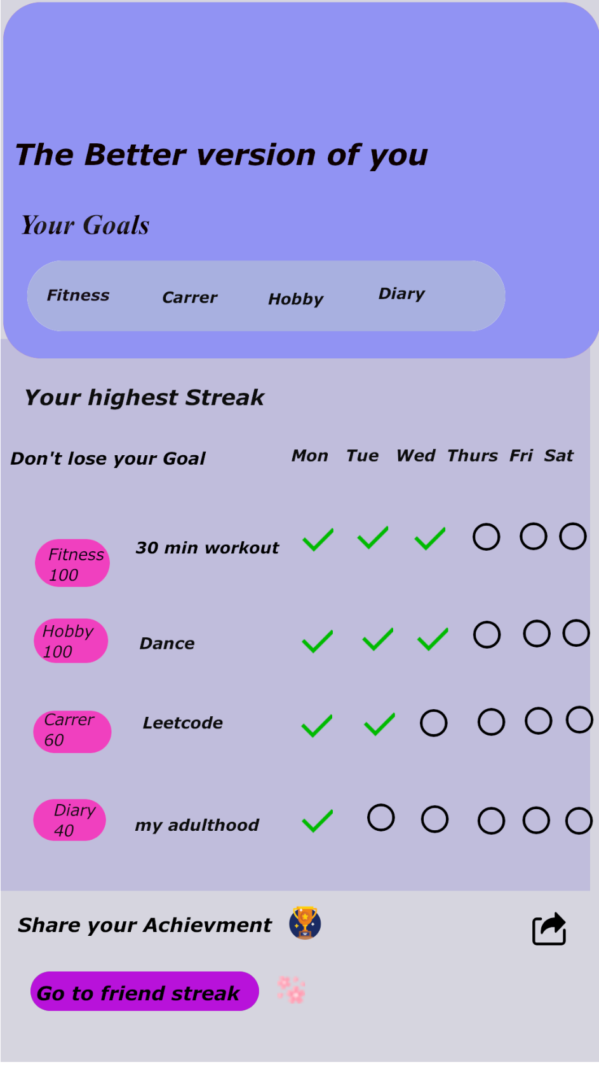

2.Final Testing:

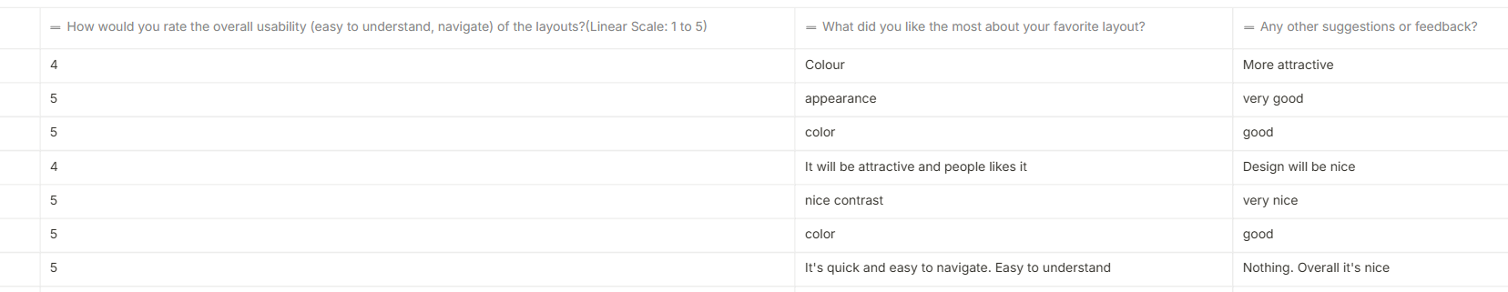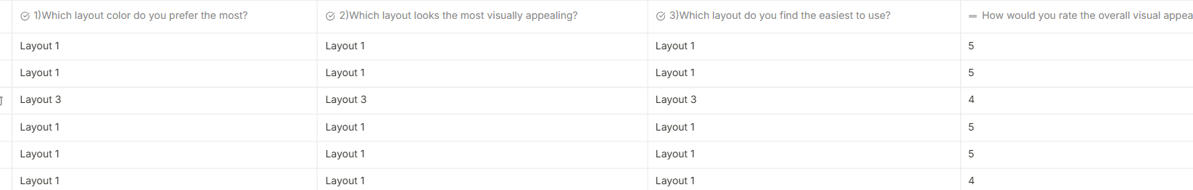

From the final layout 1 looks good and interactive, visually appealing for the customers.